Flying Committee

The CATPM Flying Committee has become very active in the past few years. Since Harvey McKinnon joined us and brought on board more professional pilots we have been able to get four of our aircraft back to flight worthy condition.
Our DH 82a Tiger Moth was taken apart and the wings moved to Lyncrest Airport and restored in the Recreational Aircraft Association’s hangar. Jill Oakes, Manitoba Director of RAA, organized the work crew and put a lot of her own time and resources into the project. The rest of the Tiger Moth was trucked to Lyncrest and the restoration was completed there.
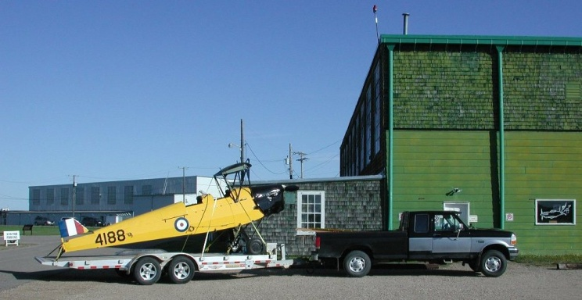
We had to overcome an issue with the engine’s cylinder heads. During WWII De Havilland used bronze castings and mild steel “training valves”. Aluminum and better steels were needed elsewhere for the war effort. Several Moths around the world have recently had engine failures as a result of the aging valves and reaction of modern fuels and the bronze. Thanks to the generosity of Dave Gillespie and Doug Tomlinson of Saskatoon who loaned the CATPM a set of Dave’s aluminum cylinder heads the Tiger Moth is back gracing the Manitoba sky with its presence.

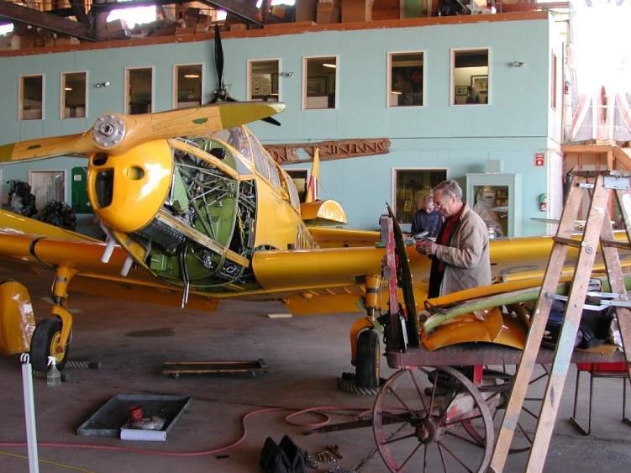
The Cornell had a very thorough “Annual” check up the last two springs and it is in fine shape. We used a modern digital inspection camera and had a good look inside of all the structures.

Each of our Pilots has taken on the record keeping and maintenance of the aircraft they fly and they have been putting in their own resources to keep the aircraft in good condition and in all cases the aircraft have been improved. We have fitted new magnetos to the Stinson and Harvard. There will always be work to do on the aircraft yet we in the Flying Committee enjoy the work and the results.
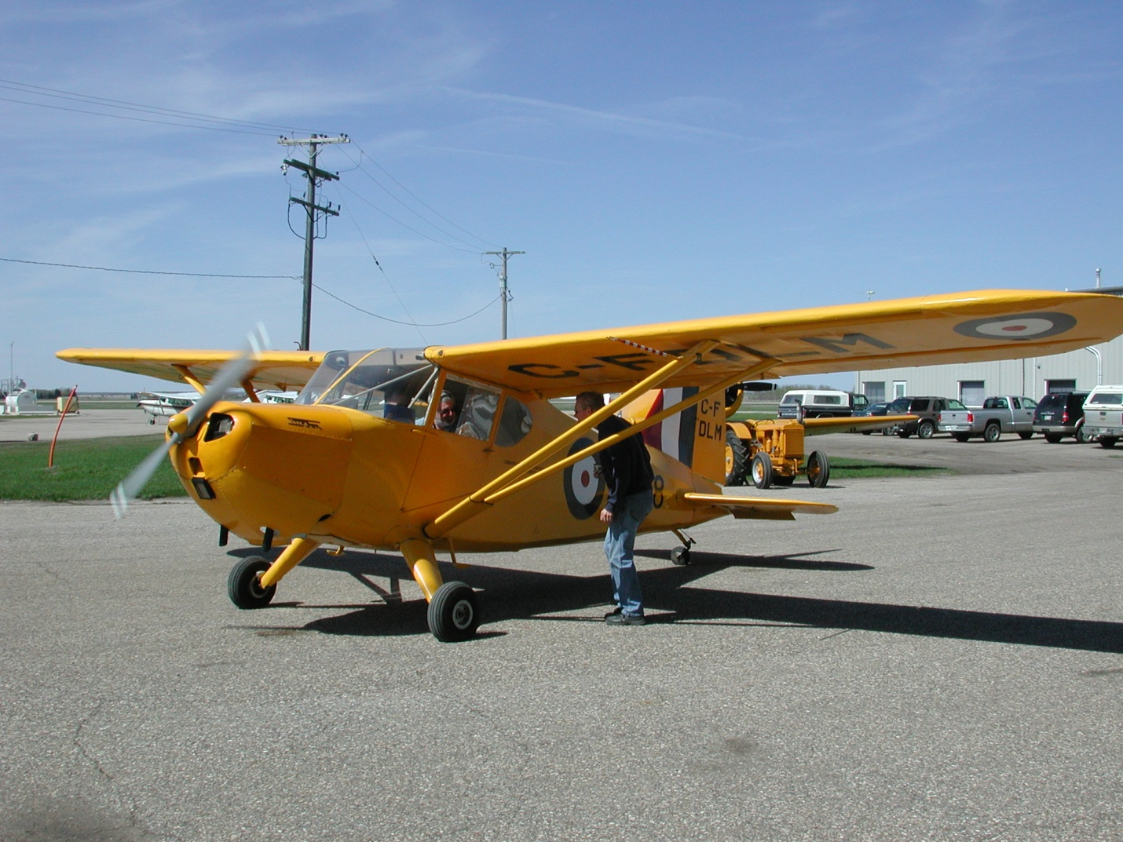
Harvey Peter and Al with the Stinson’s first run of the year.
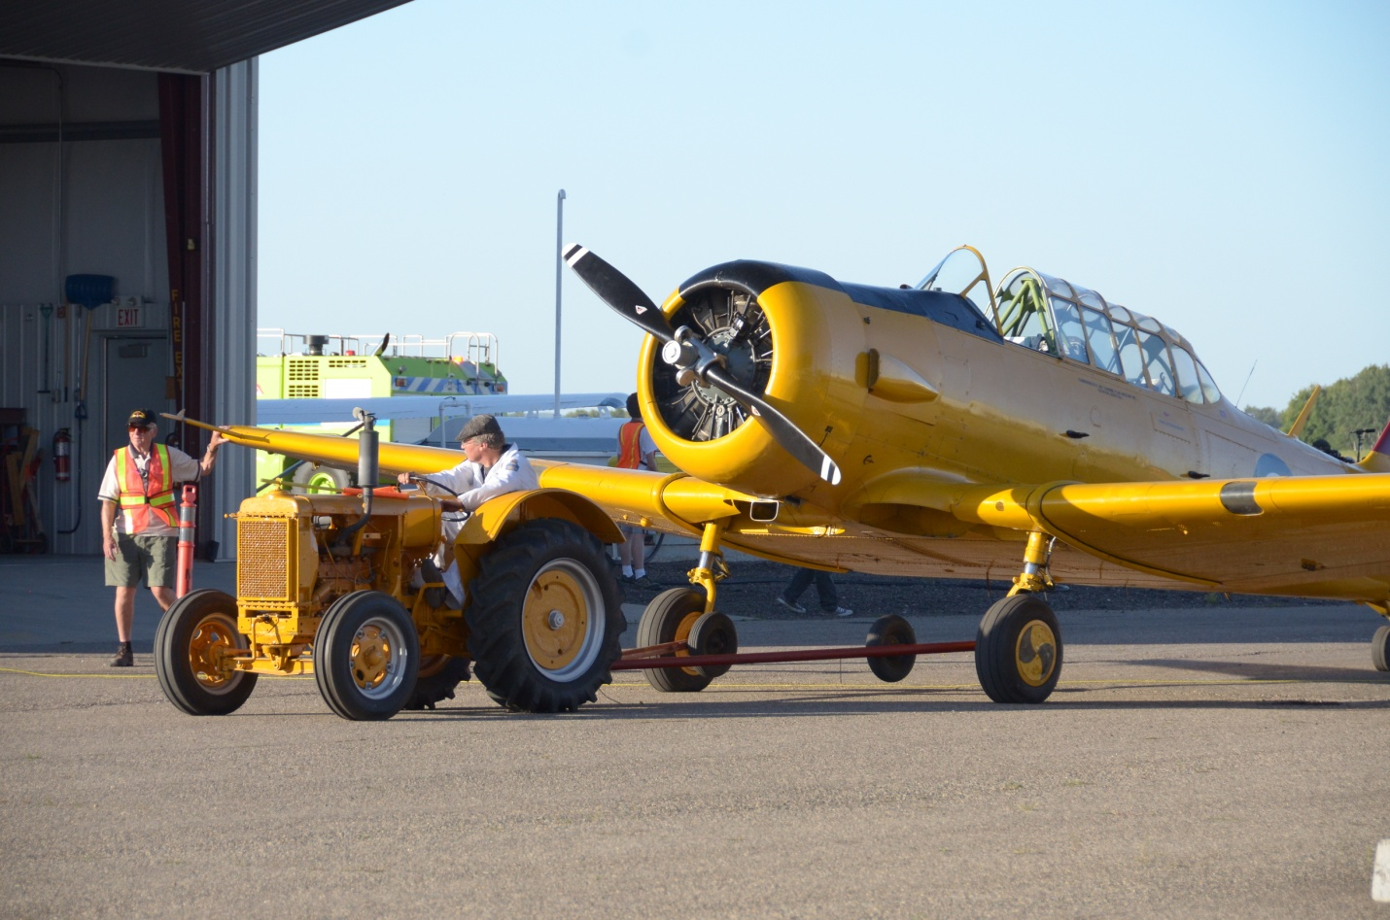
Our 1938 International I 14 industrial tractor served at #3 Bombing and Gunnery School, McDonald Manitoba during the war and is still moving aircraft of the BCATP. Here it is towing our Harvard 2557 back to the ramp after the Harvard’s show performance.

The Flying committee organized two successful Air Demonstration Days this August, one in Dauphin, the other at the CATPM. Thousands of people got to see our air craft this summer. The Tiger, Stinson, Cornell and Harvard flew to Kenora Ontario and were on display there as ambassadors for the CATPM. Ross Robinson returned with his Harvard Mk IV and Douglas A-26 Invader.
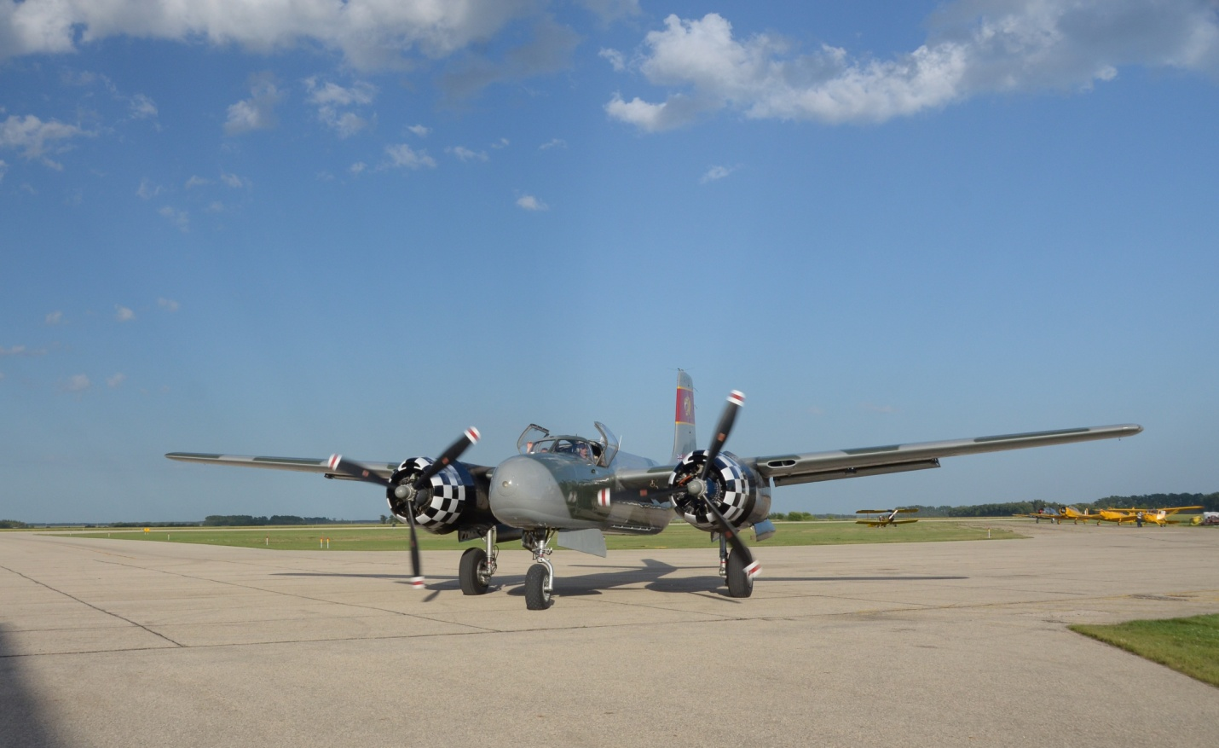
The A-26 Invader returning to the ramp in Dauphin after Al Nimo put on a very nice “Fly By” display for the crowd.

The Commemorative Air Force from Mesa Arizona brought their B-17G “Sentimental Journey” to share with us. Many around Brandon and Dauphin had the privilege of touring the aircraft and many took a ride in the B17 while it stayed in Brandon for 3 days. Many people of Brandon and area got to see the B-17 in the air over the city in the days before our event.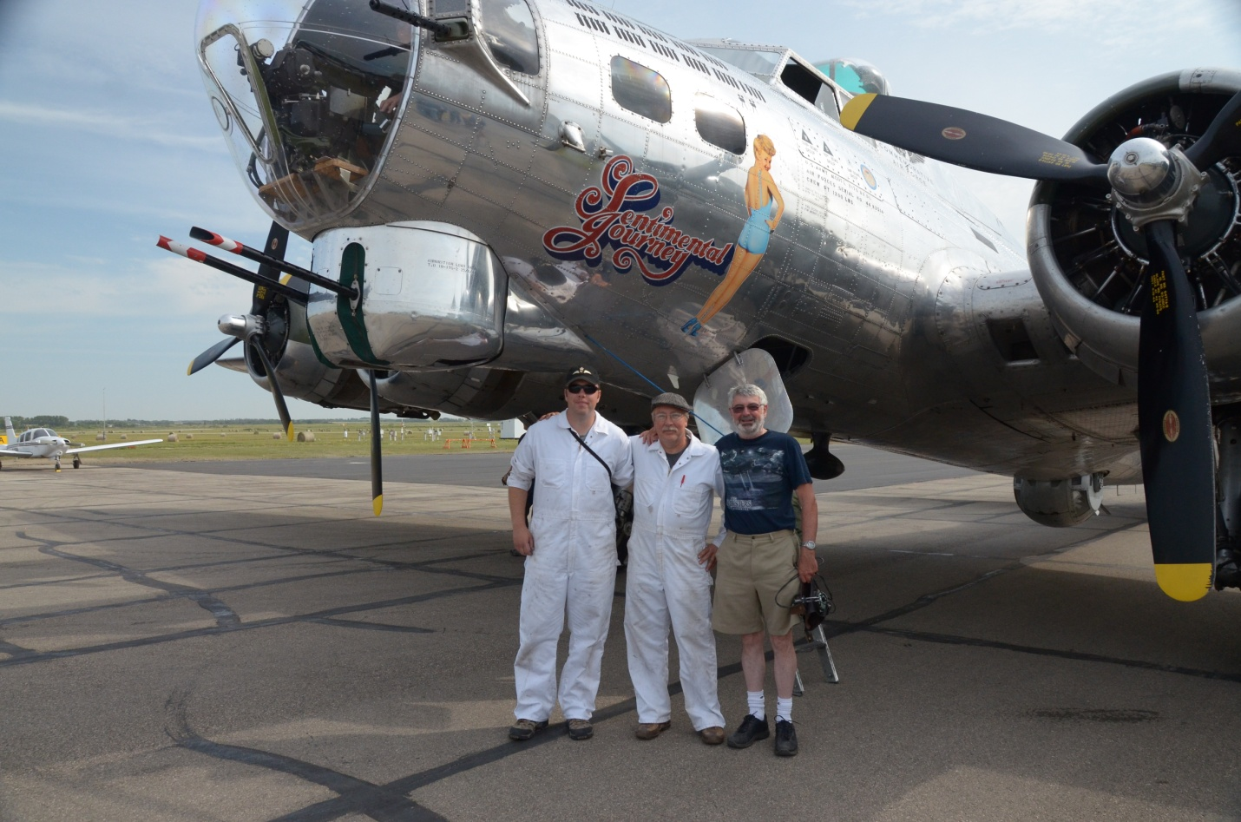
Big smiles from Al and John McNarry our “ground crew” and Peter Moodie our Cornell pilot after flying to Yorkton with the B-17. Al and Peter returned to Yorkton with the Cornell.

Thursday August 22nd was our CATPM Flying Demonstration Day The event was a real treat for 1700 paying adults and their children who attended our event for free. Tours of the B-17 continued and during the afternoon the Hangar was open. Guests were entertained by members of the RCAF Command Band and Women of the War Years served refreshments. The ramp was open to the public with static and operational aircraft and Motor Transport vehicles available for up close and personal inspection by the public. The Brandon RAA chapter and several volunteers from the museum patrolled the ramp and guided visitors. Many children and interested adults had the privilege of sitting in the cockpits and having the aircraft explained to them by our pilots, ground crew and veterans. Some ground crew wore white coveralls in respect of the ground crew riggers and fitters who serviced aircraft during WWII. Our four aircraft performed “Fly Bys” as well as the A26 and B17 flying past the crowd at 200 feet AGL. Ed Moon brought his T28 Trojan a Korean War era US Navy aircraft for us to enjoy. Two homebuilt aircraft a Steen Skybolt and a RV 8 also performed “Fly Bys”. The Gift Shop and Ladies Auxiliary did a good business selling souvenirs and hotdogs.
It took so many more people than just pilots to make the BCATP a success and the same is true of our event. Thanks to museum members, parking attendants, the ladies who prepared food for the volunteers and all the rest who gave time to make these events possible and successful.
Our Cornell also flew the Cornell to Yorkton to give our museum a presence at Yorkton’s B-17 event. The Stinson and Cornell also flew to Winnipeg to participate in the RCAF 17 Wing’s Battle of Britain commemoration. Flying committee had a very successful year and wishes to thank all involved.
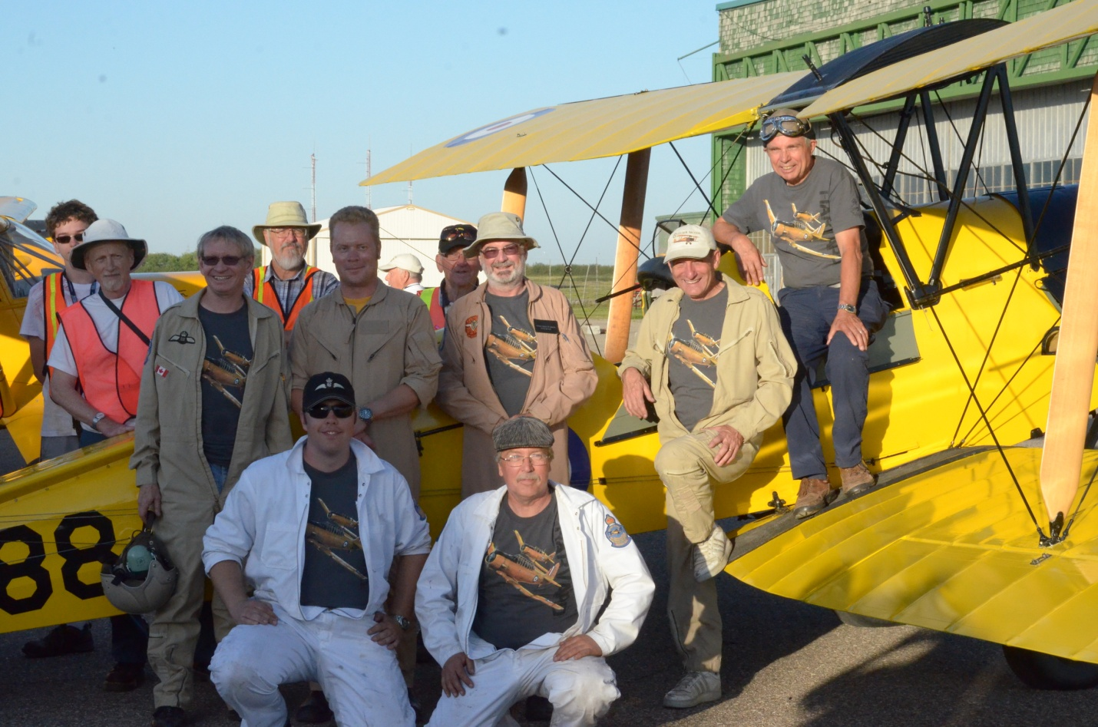

The Flying Committee: Ground Crew; Alan and John Mcnarry
Pilots; Harvey McKinnon, Al Fillingham, Peter Moodie, Dave Gillespie, Jim Oke

Behind the Tiger are RAA members; John Robinson, Dave Walker, Gary Gerard
Jacob Wolfe a new younger volunteer
(and in the background our own dedicated volunteer Angus Sneesby facing away from the camera!)
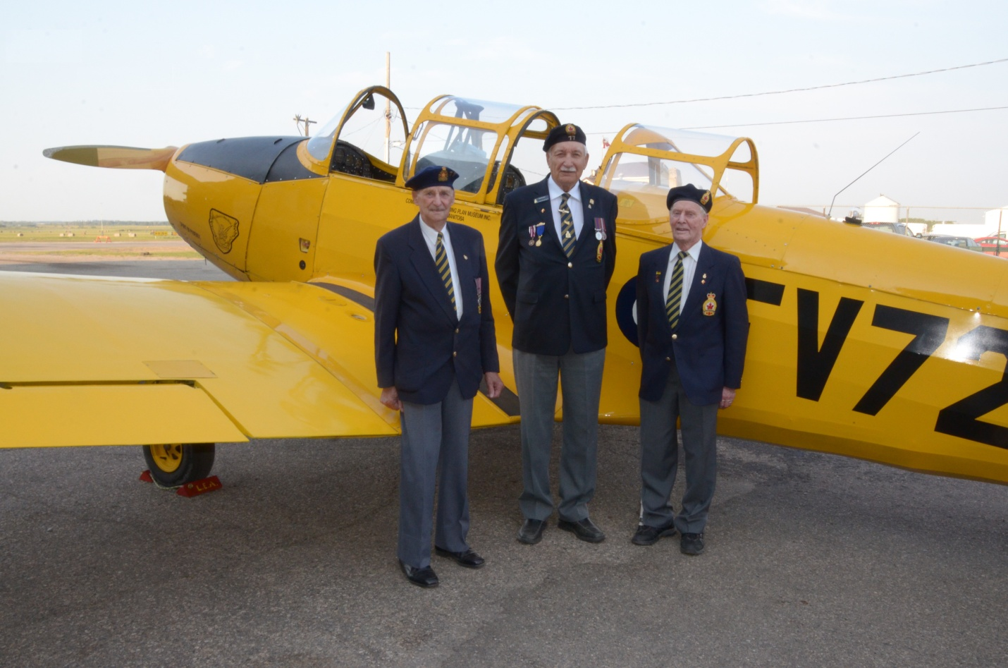

Veterans at Yorkton with our Cornell.

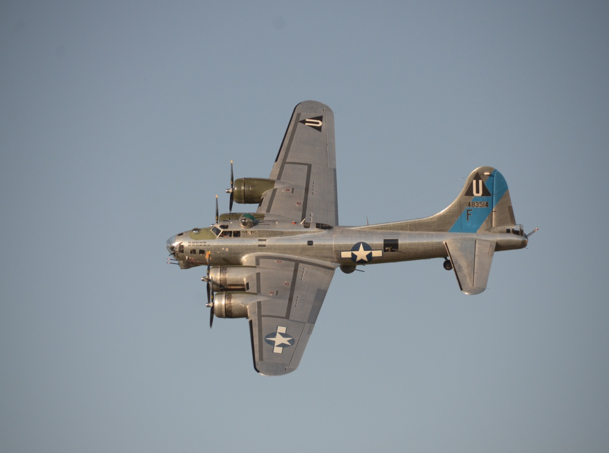

B-17G Sentimental Journey

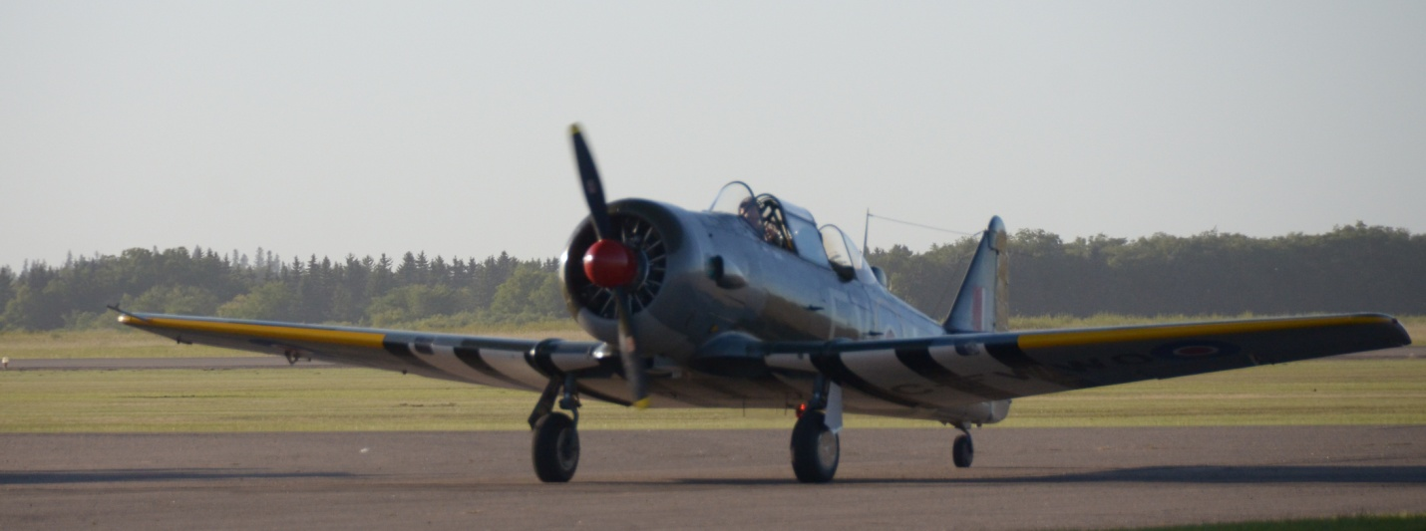

Ross Robinson’s Mk IV Harvard
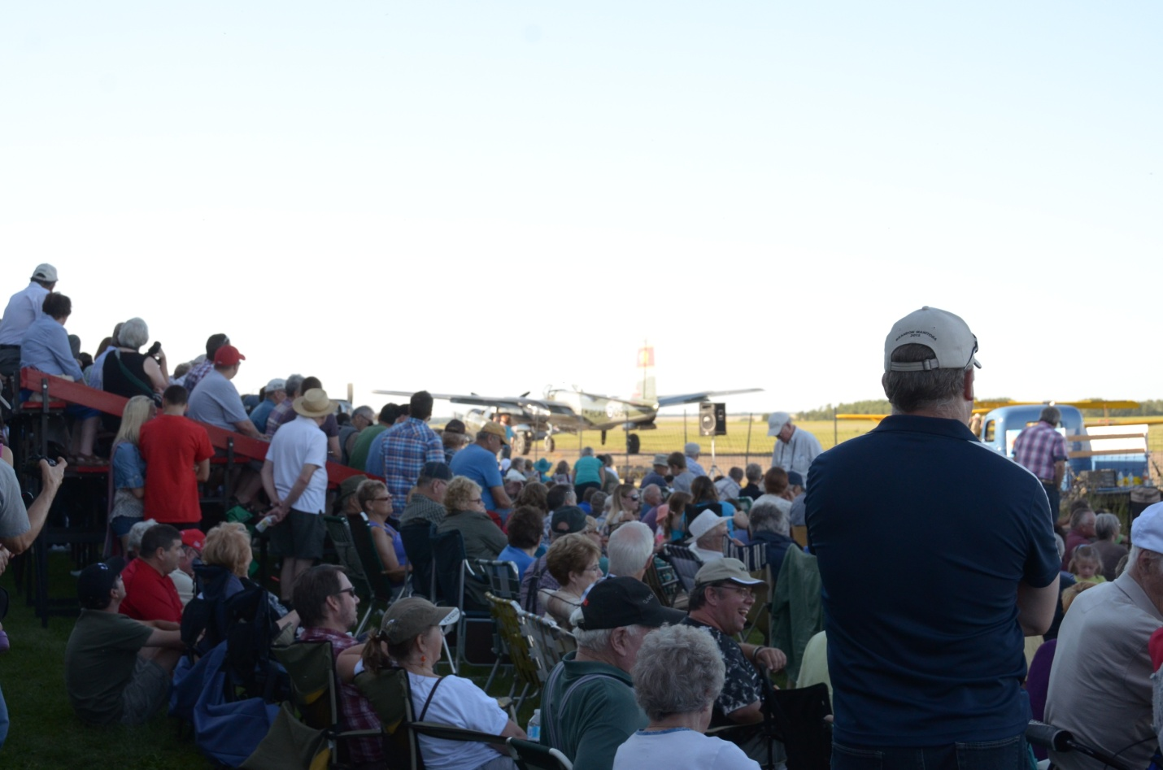
Crowd east of Hangar viewing Air Show

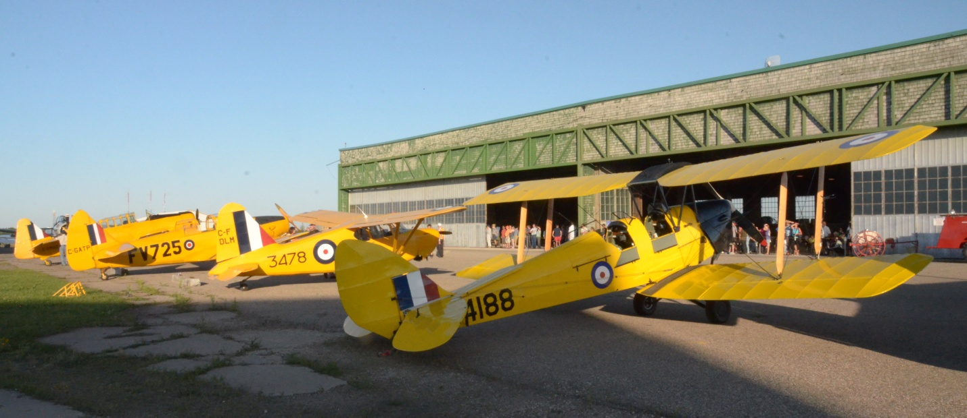
Yellow Airplanes
Perhaps we’ll do it all again next year . . .

John McNarry for the CATPM Flying Committee

